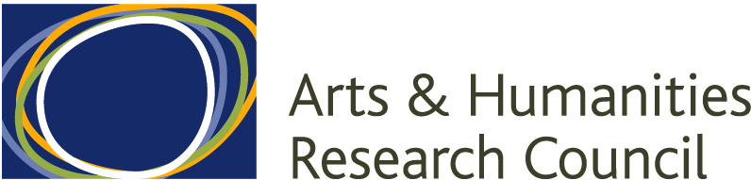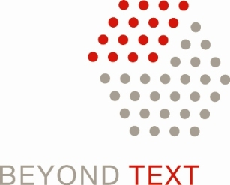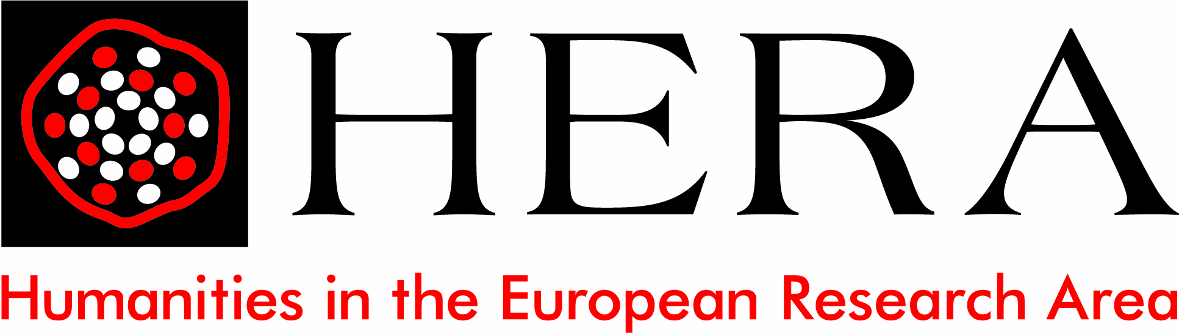

Beyond Copyright workshop
Roy Goode Room, Intellectual Property Institute
Centre for Commercial Law Studies, 67-69 Lincoln’s Inn Fields
London WC2A 3JB

Agenda
08 April 2011

09.30 Coffee and Registration

10.00 Welcome: Professor Rick Rylance, Executive Director, AHRC

10.15 Are there alternatives to copyright? An Arts and Humanities Perspective
Professor Evelyn Welch, Queen Mary University of London and AHRC Programme Director, Beyond Text

10.35 Creators, Copyright, Innovation and the Internet
Dr Jeremy Silver, Mediaclarity

10.55 Has copyright outlived its usefulness?
Bill Thompson, Head of Partnership Development, BBC Archive

11.15 Coffee

11.30 Music and Dance: Beyond Copyright Text? (AHRC)
Professor Charlotte Waelde, University of Exeter

11.50 Who Owns the Orphans? Traditional & Digital Property in Visual Art (AHRC) Professor Uma Suthersanen, QMUL

12.10 Copyright and Creativity (HERA)
Professor Helle Porsdam, University of Copenhagen

12.30 Of Authorship and Originality (HERA)
Dr Mireille van Eechoud, University of Amsterdam

Beyond Copyright

13.00 Lunch

14.00 Workshop sessions

15.00 Tea/Coffee

15.30 Feedback and discussion

16.00 Next Steps: Professor Rick Rylance

